**Home page:**

This is the page that is seen when we first open the portal, and we’re not logged in. That is why we see “Hello Guest” in the top right corner, and the dropdown for the user gives only the “Log In” option. This will change once we’re logged in, by choosing the Log In option from the dropdown.

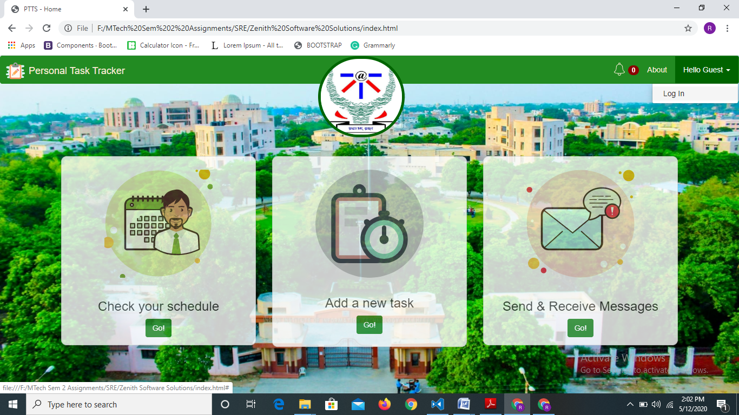

**Log In-**

We don’t require registration on this portal as we are using LDAP credentials for Login, which every person in IIIT already has. From the back-end, we can configure permissions for only the required IDs.

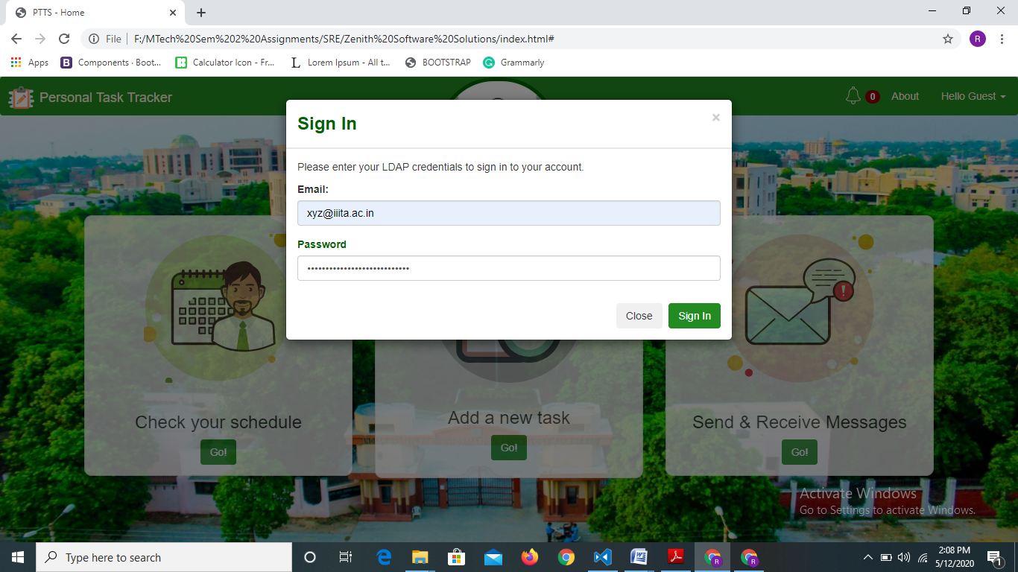

After login, the home page displays the name of the user in the top right corner and the dropdown options change, as displayed below.

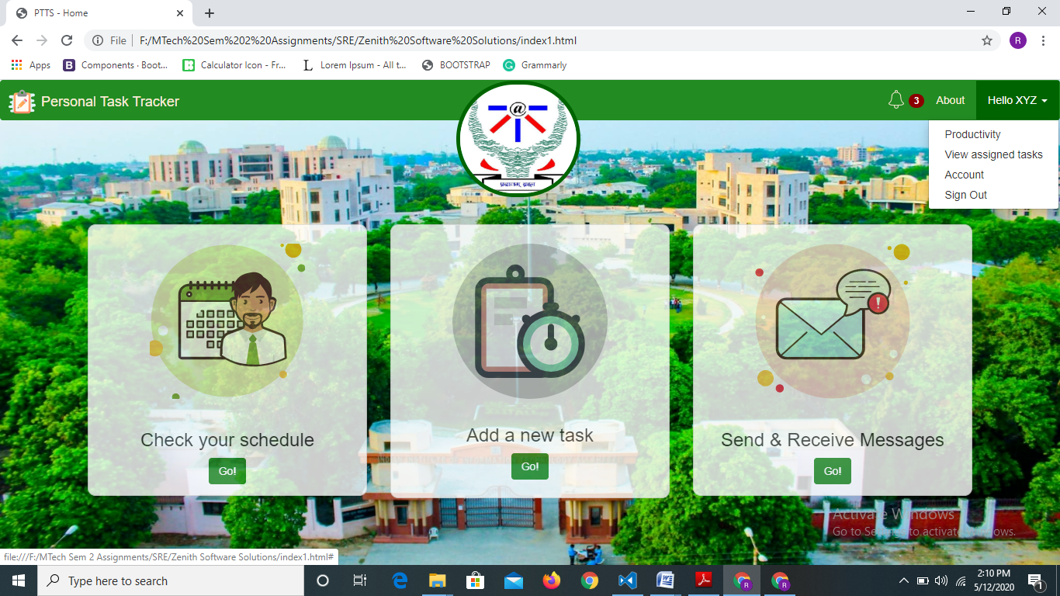

When a Chair user logs in i.e. Director or HOD, there is an extra option to track all faculties i.e. “Comparative Productivity”.

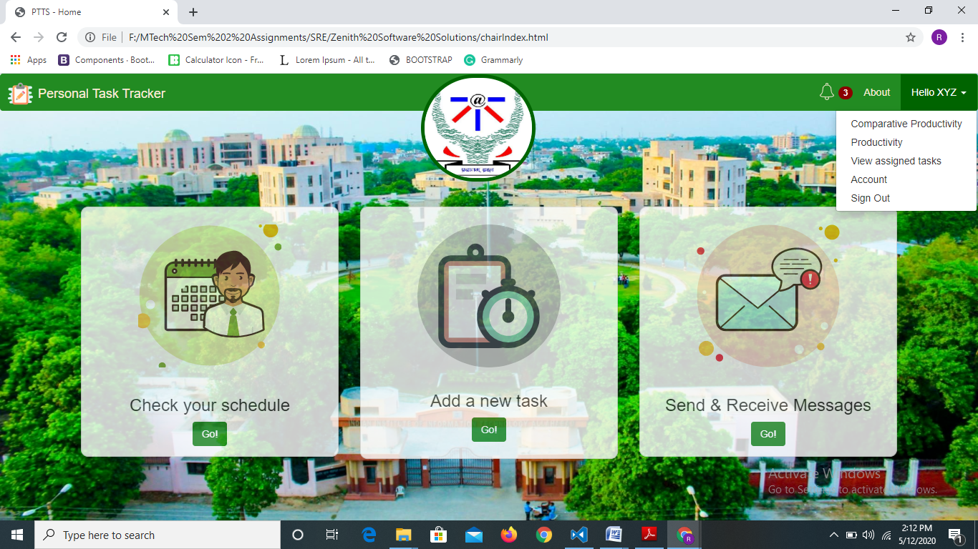

The entire portal adapts as per the Chair user to enable him/her to assign tasks, view faculty members and successfully accomplish other required activities.

**Checking Schedule:**

One can check one’s schedule by clicking on the first thumbnail on the Home page after logging in, which says “Check your Schedule”. The thumbnail becomes opaque when active.

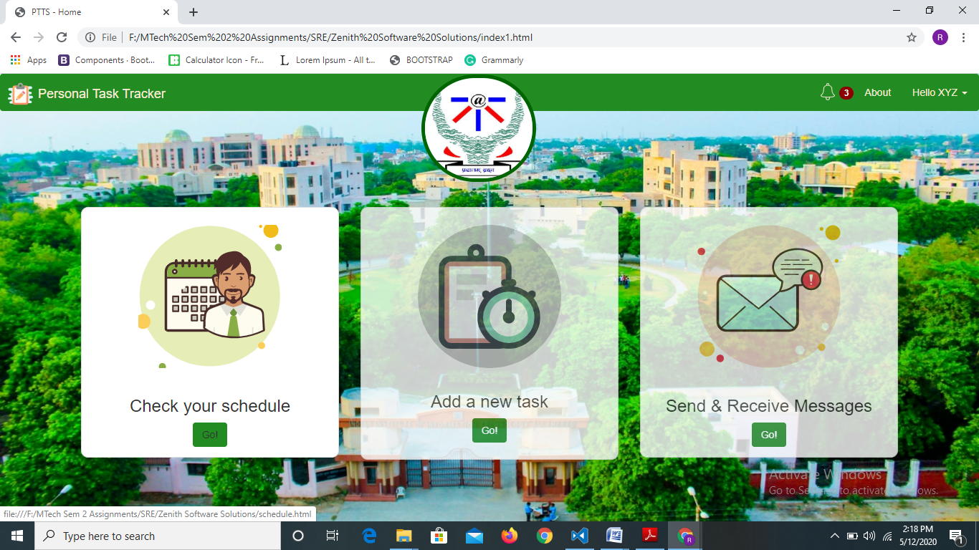

The schedule page appears where we can input a date and the time table for that day appears.

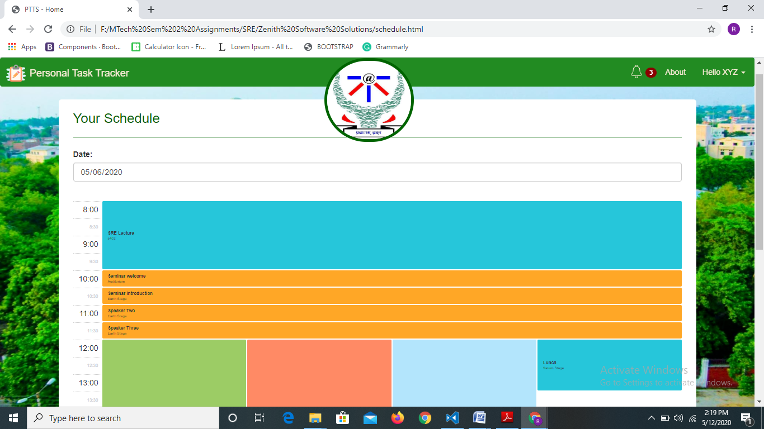

For input facilitation, a calendar appears when we try to input the date. This feature is there for all date inputs in the portal.

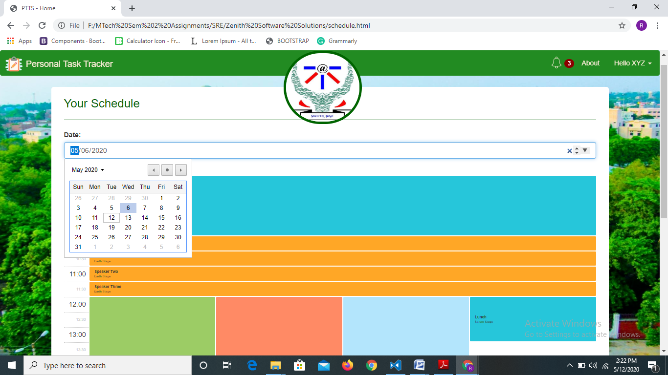

**Task creation:**

We can create and assign new tasks using the “Add a new task” thumbnail on the home page.

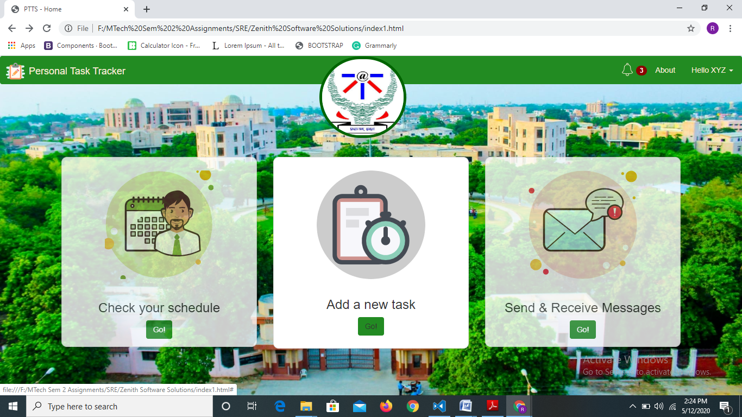

The “New Task” form appears when we click on it. We can fill the form to create a new task.

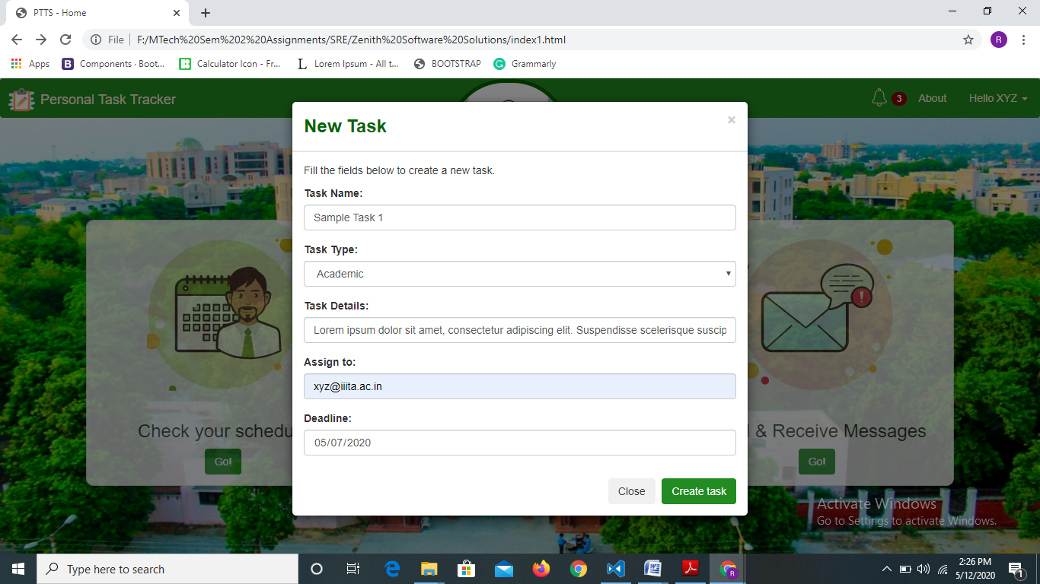

We can configure appropriate task assignment permissions from the back-end. For instance, a faculty member should be able to assign tasks only to herself/himself, while the HOD can assign tasks to anyone in his/her department. The Director should be able to assign tasks to anyone in the Institute.

One can select from any of the 3 available task types i.e. Academic, Extra-curricular and Research.

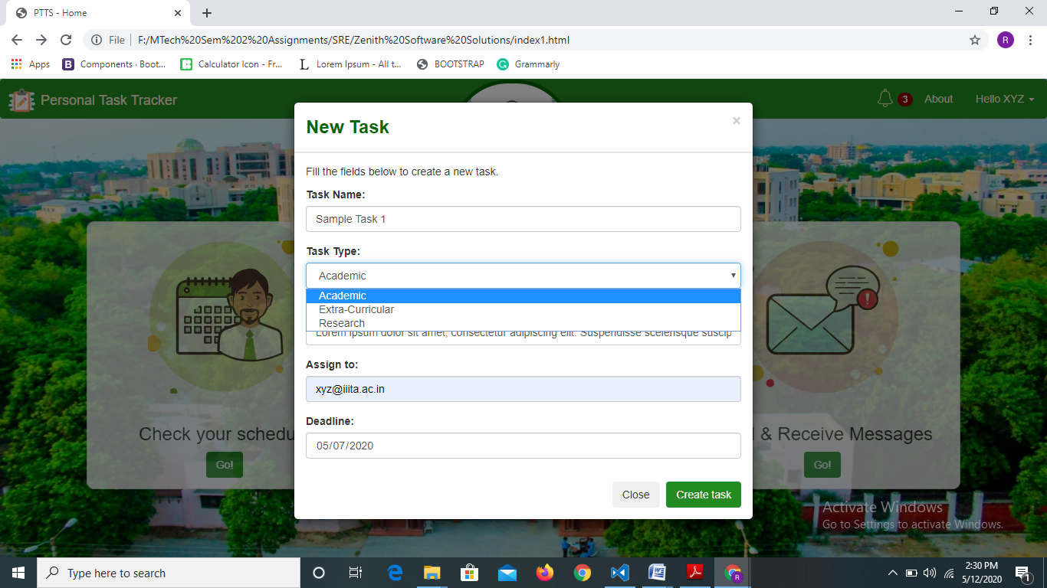

Here also, the date input supports a calendar dropdown for better UX.

**Messages-**

One can send or receive message using the “Send & Receive Messages” thumbnail on the Home page.

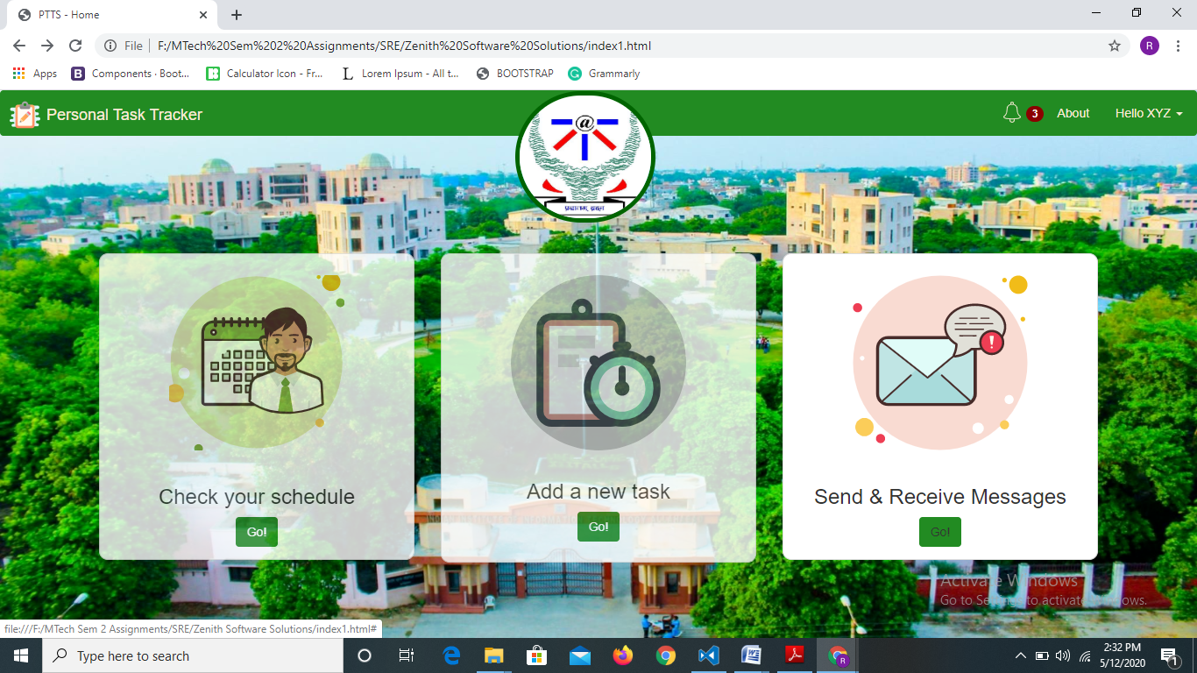

When we click on “Go!”, the **received messages in our inbox** appear.

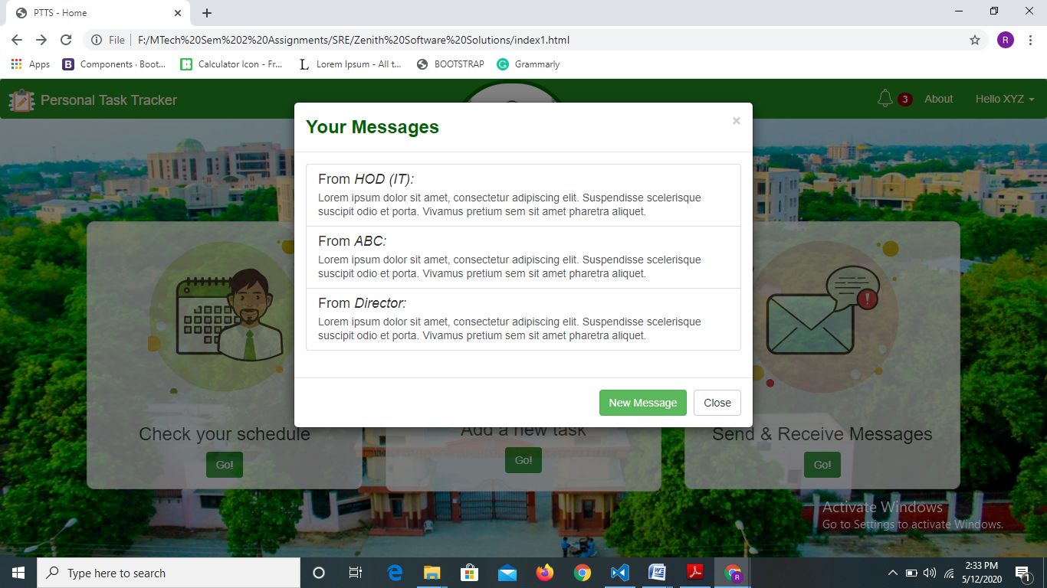

In order to **send a new message**, we can use the “New Message” button shown above. Clicking on it displays a “New Message” form. We can send group messages or individual messages, by simply using the individual email ID or group email ID provided by the institute.

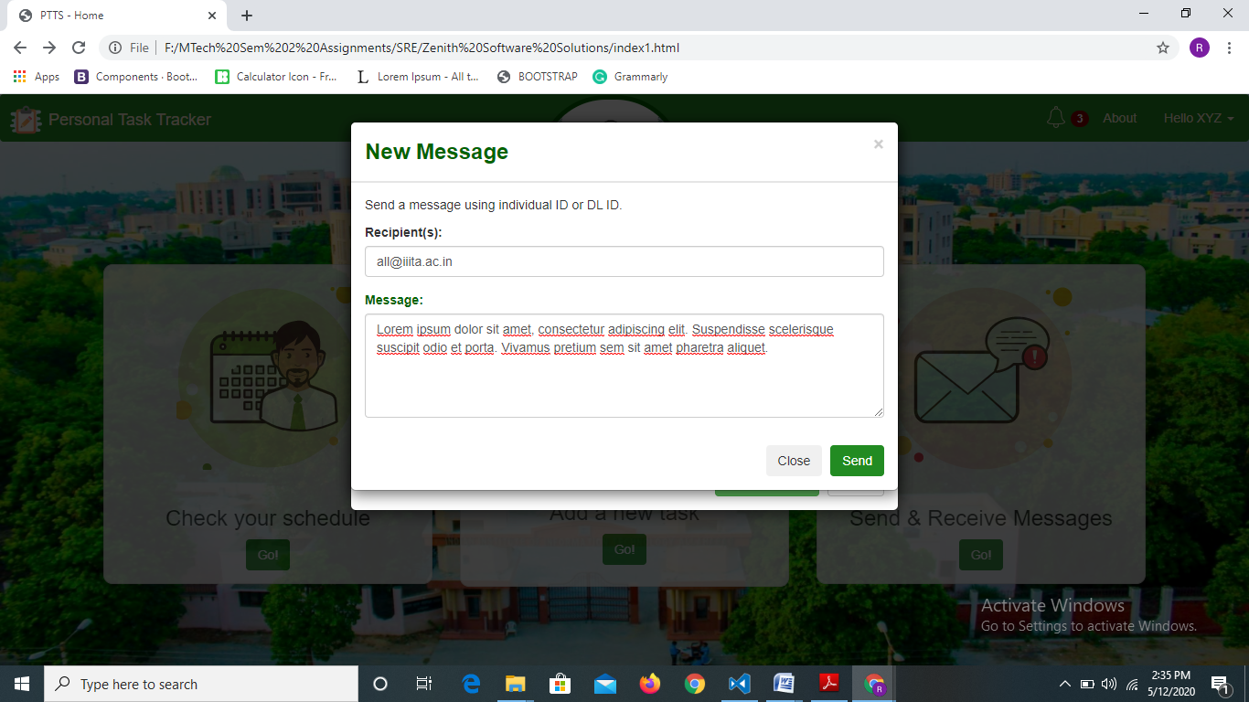

**Notifications-**

We can check our notifications by clicking on the Bell icon on the navbar, which shows the number of active notifications.

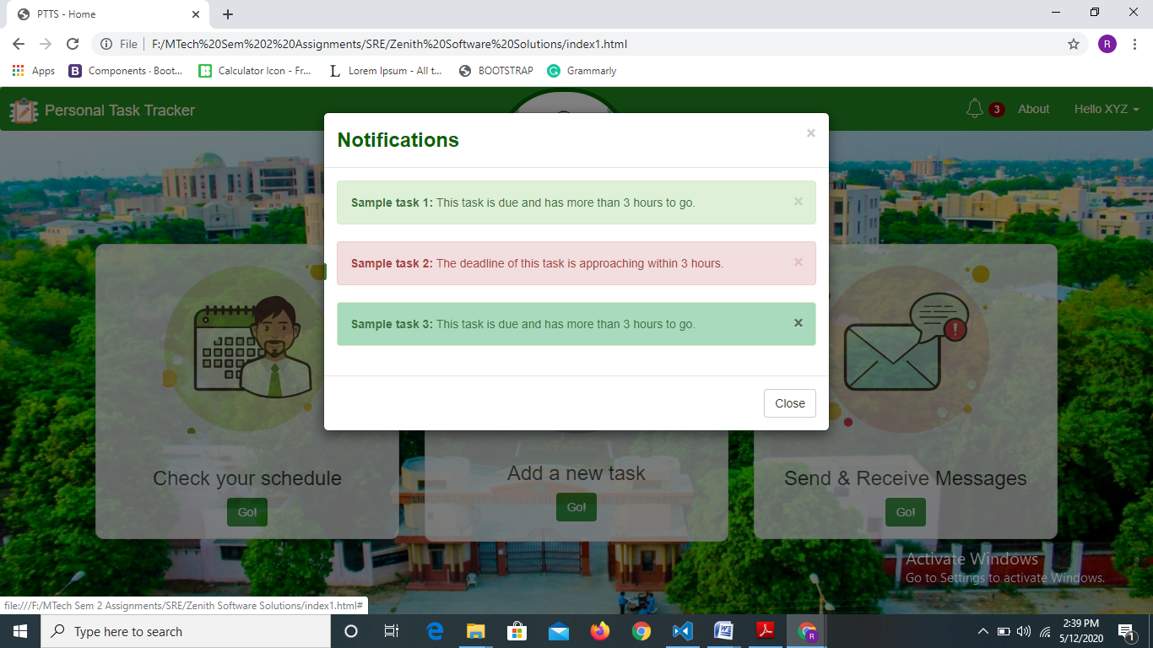

We can snooze a notification by clicking on the “X” icon next to the notification. For better UX, tasks with deadlines approaching within 3 hours are highlighted in red.

**Tracking Self Productivity-**

Self productivity in a given date range can be tracked using the “Productivity” option on the home page as shown below.

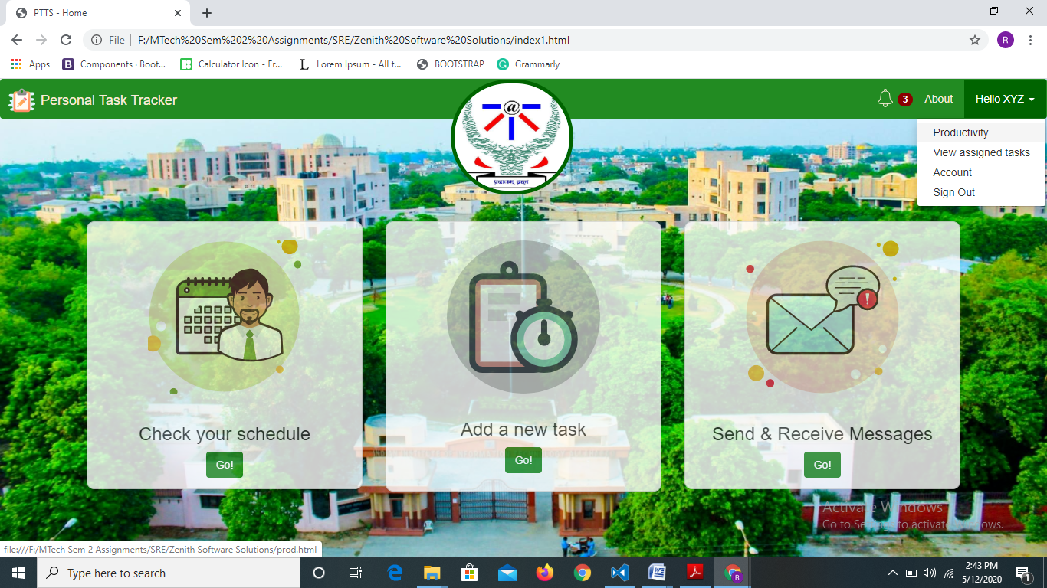

Choosing that option makes the Productivity page appear on the screen, where we need to input a date range. Doing so makes a histogram with the required details appear on the page. The legend is also given for better understanding.

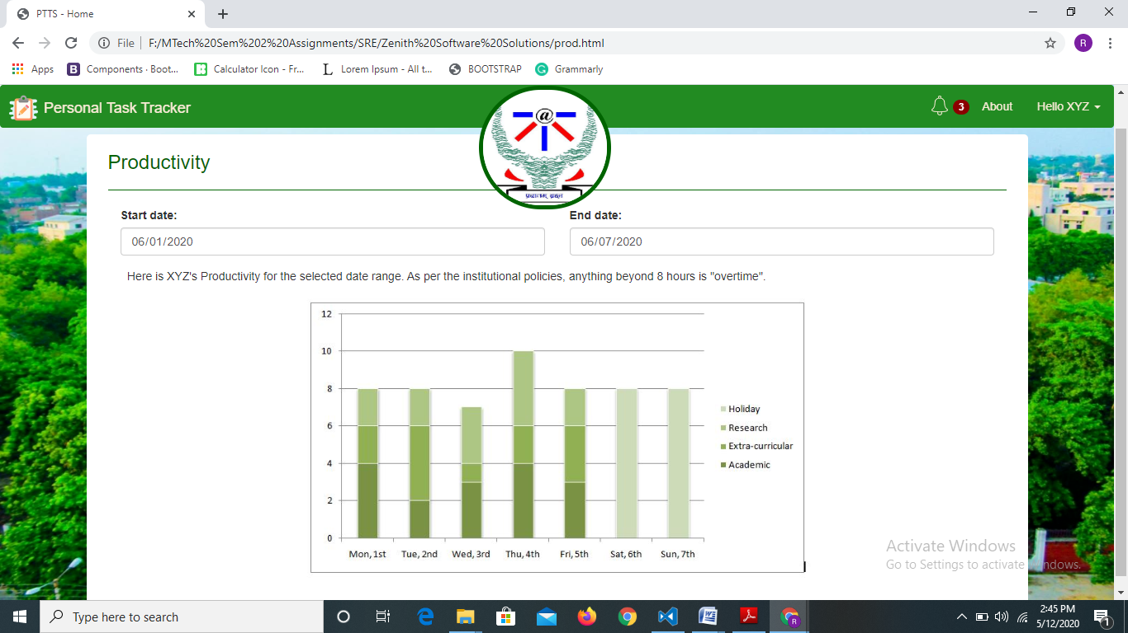

**Track productivity of all faculty members-**

This feature is available only for chair users. While the HOD can track those under his/her department, the Director can view the histogram for all faculties. This histogram can be seen by choosing the “Comparative Productivity” option only for Chair users.

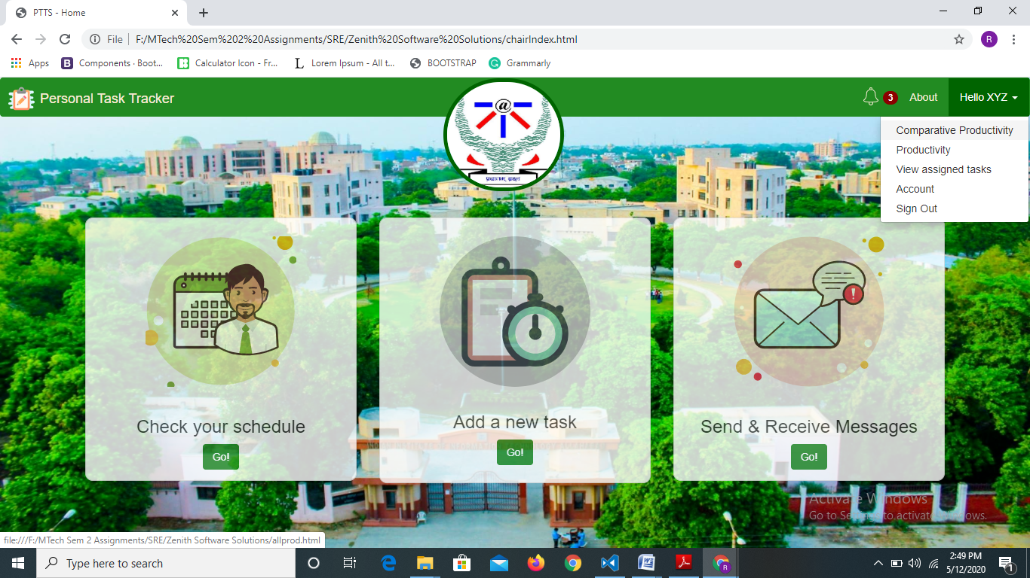

Selecting this option asks us for an input date, and a chart with a bar for each faculty under the current user’s supervision is shown. Appropriate task break-up with leaves, academic and other types is shown.

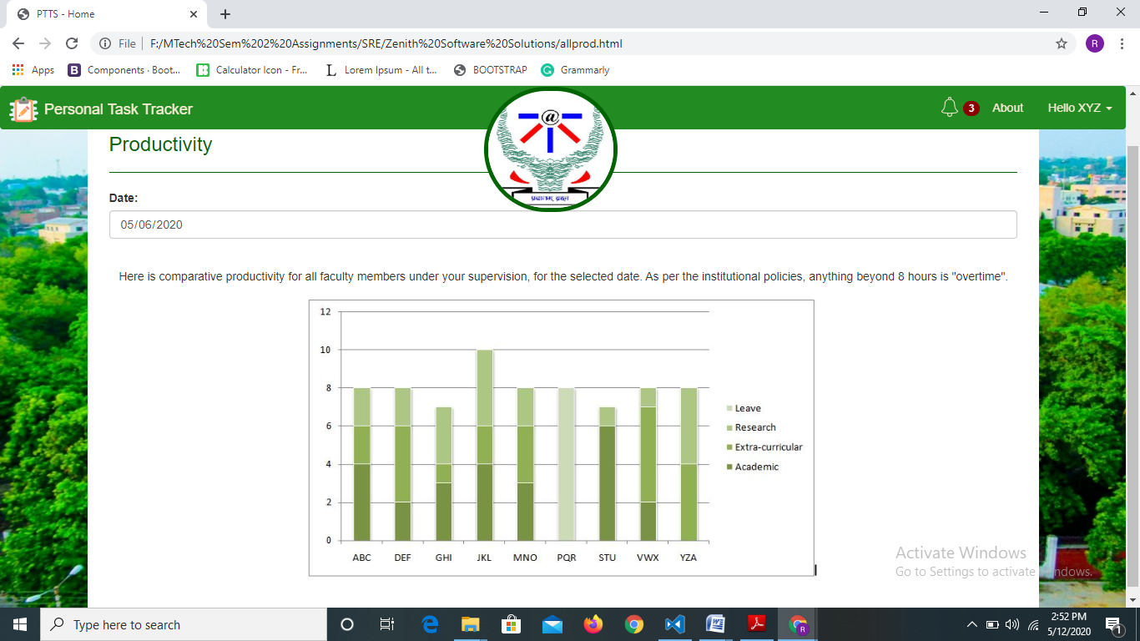

This is a hypothetical scenario shown above where XYZ is an HOD and has 9 faculty members in his department apart from himself.

**View Assigned Tasks-**

One can view the list of assigned tasks by choosing the “View assigned tasks” option.

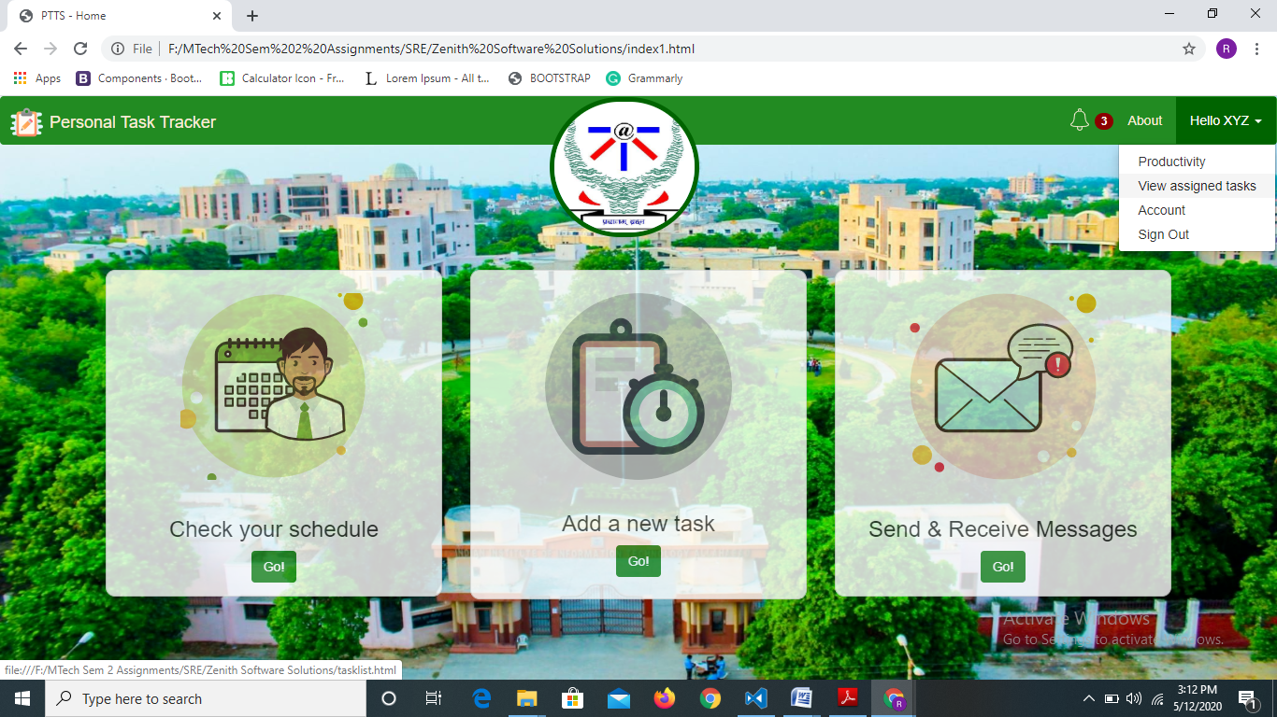

Then we need to input a date and all the tasks assigned for that date are shown.

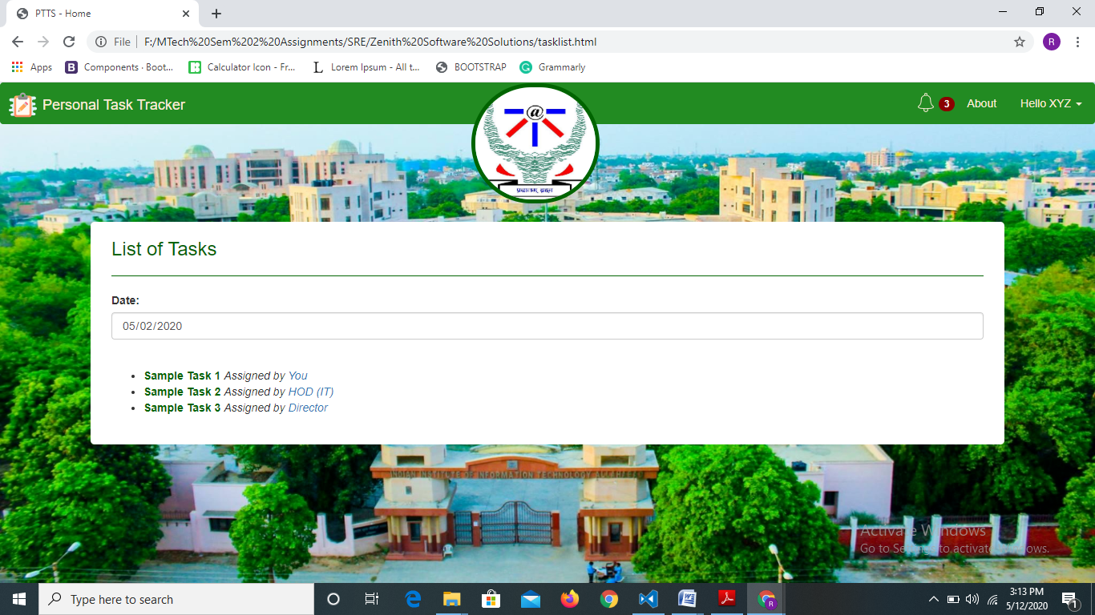

Clicking on any task will open the page for that particular task showing full details of it.

**View/Update task progress-**

The progress of a particular task can be viewed by clicking on the task name in the “List of Tasks”.

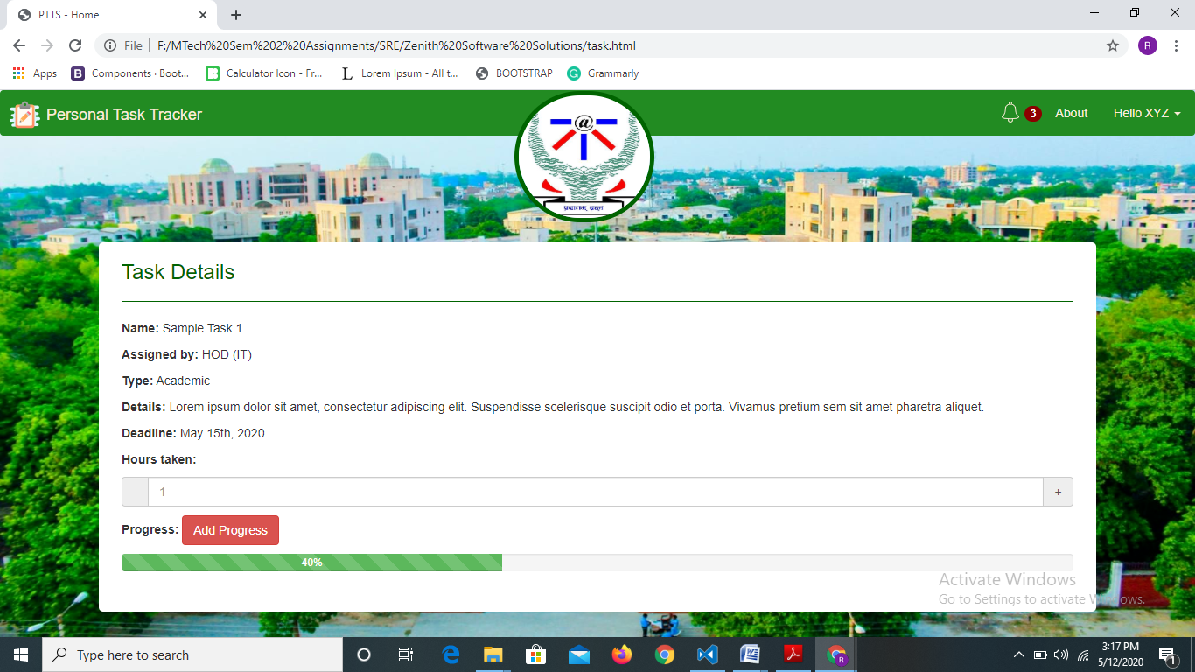

One can update the hours taken here, which would also reflect in the histograms. Also, progress can be updated up to 100% using the add progress button which adds 5% to the current progress every time we click it.

**View Account Details-**

One can view his/her account or profile details by choosing the “Account” option through the navbar dropdown as shown below.

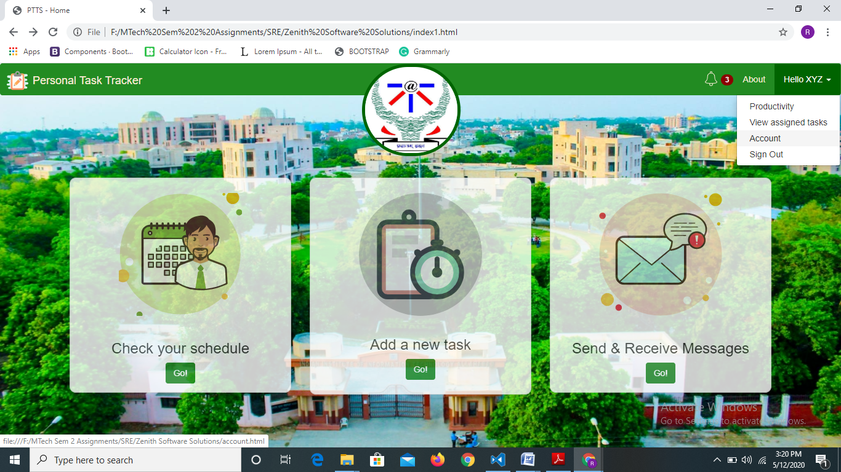

This reveals the account page with all the details of the logged in faculty member like designation, department, joining date, area of interest, picture, etc.

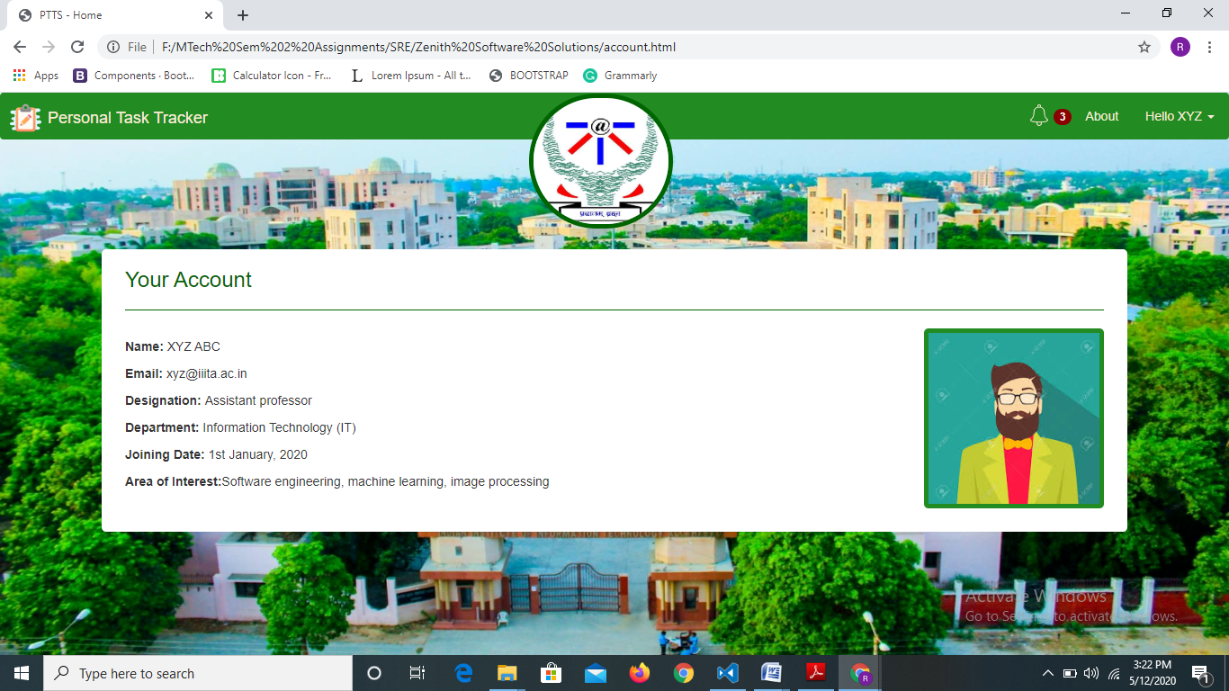

**Sign out/log out-**

Choosing this option from the navbar dropdown, as shown below, logs a user out of his/her account.

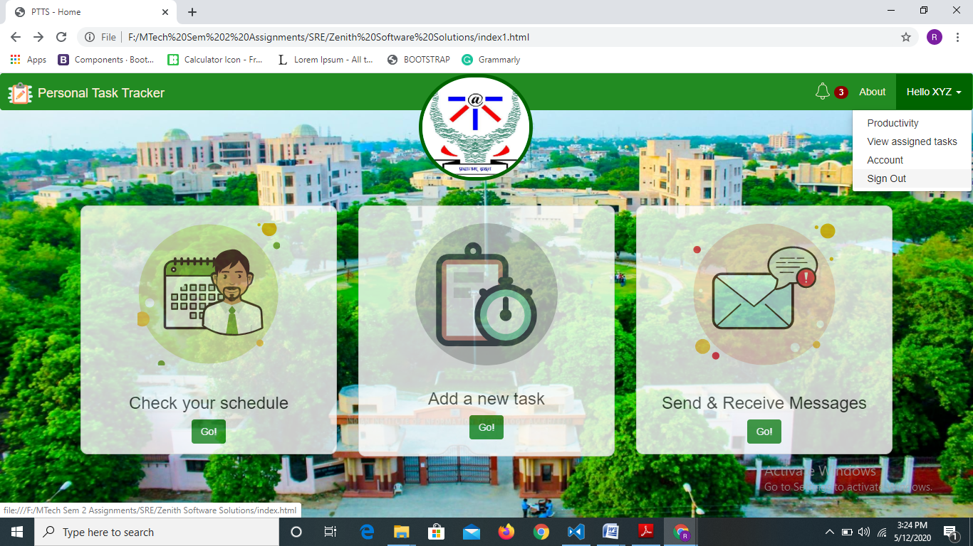

**About page-**

The about page offers a brief description of the portal and its usage. It also serves to offer credits to the software company that designed it, as shown below.

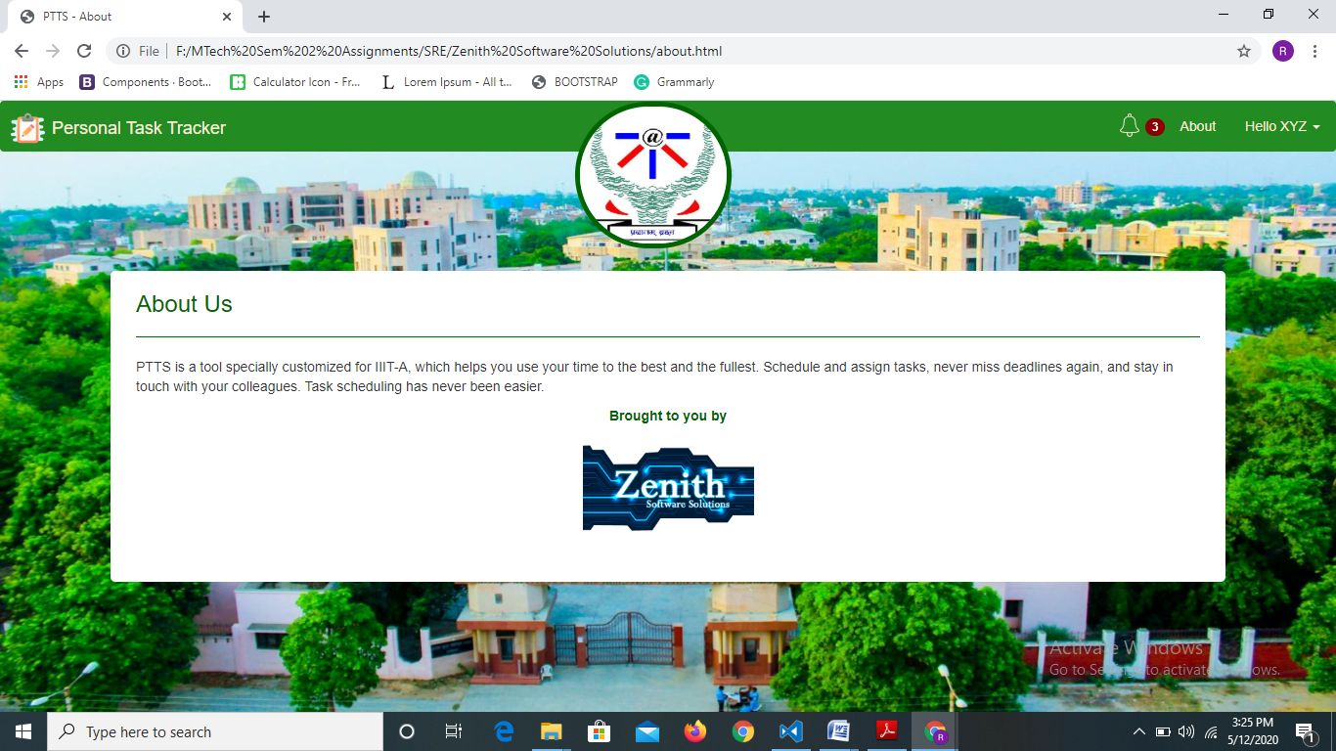

**Extras-**

The UI is fully responsive in nature to allow users to use it through their handheld devices with equal ease. The screenshot below shows how it looks on a mobile screen. The navbar stays put at the top of the screen always, so that one can always navigate to all pages in the portal through it. Clicking on the “Personal Task Tracker” banner or the college logo always takes us back to the homepage from everywhere.

